Name manar ibrahim attia

Section 7

The answer

* The first question :

Load :-

Pc : 300

Ac : 0003

IR : 1940

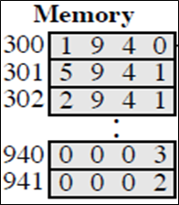

Add :- PC : 301

AC : 0005

IR : 5941

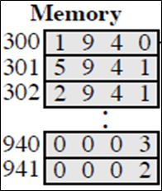

Store :

PC : 302

AC : 0000

IR : 2941

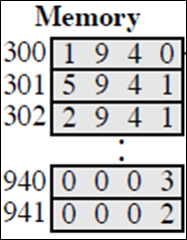

* The second question :

|  |  |
| --- | --- |
| Load | |
| **300 – 1550** | |
| **301 – 5551** | |
| **302 – 2600** | |

|  |
| --- |
| **550 – 0003** |
| **551 – 0004** |
| **600 – 0000** |

|  |
| --- |
| **PC : 300** |
| **AC : 0003** |
| **IR : 1550** |

|  |  |
| --- | --- |
| Add | |
| **300 – 1550** |
| **301 – 5551** |
| **302 – 2600** |

|  |
| --- |
| **550 – 0003** |
| **551 – 0004** |
| **600 – 0000** |

|  |
| --- |
| **PC :301** |
| **AC : 0007** |
| **IR : 5551** |

|  |  |
| --- | --- |
| store | |
| **300 – 1550** |
| **301 – 5551** |
| **302 – 2600** |

|  |
| --- |
| **550 – ­­­­­­0003** |
| **551 – 0004** |
| **600 – 0007** |

|  |
| --- |
| **PC : 302** |
| **AC : 0000** |
| **IR : 2600** |

* The third question :

|  |
| --- |
| **300 – 3005** |
| **301 – 5940** |
| **302 – 7006** |

|  |
| --- |
| **Device 5 : 0003** |
| **940 : 2** |
| **Device 6 : 0005** |